**Solution:**

|  |  |
| --- | --- |
| **Words** | **Accuracy(%)** |
| 3000 | 71.14 |
| 5000 | 71.72 |

**Pictures:**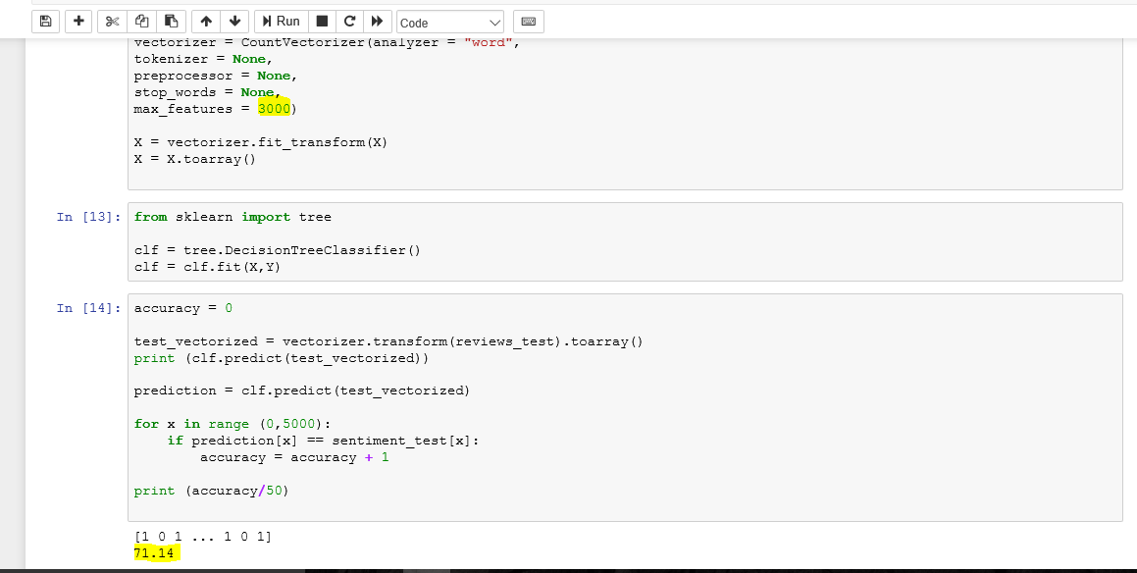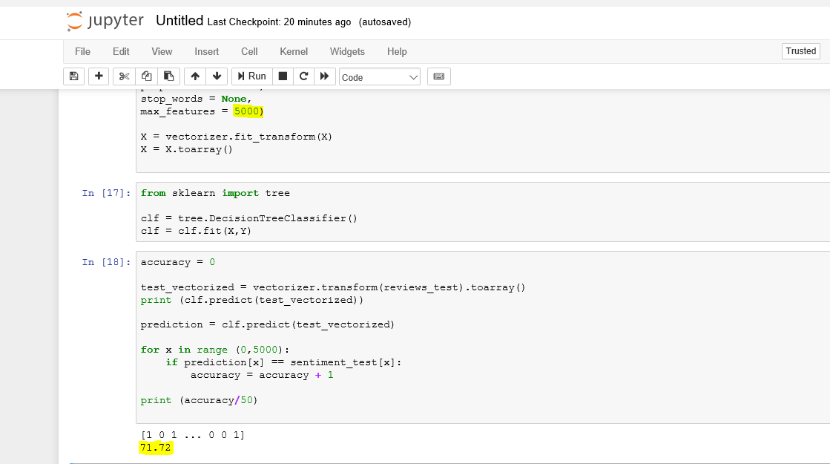

**Code:  
1:**  
import pandas as pd

import re

import nltk

import numpy as np

from bs4 import BeautifulSoup

from nltk.corpus import stopwords

# Run the BeautifulSoup object on a single movie review

pd.options.mode.chained_assignment = None

train = pd.read_csv('labeledTrainData.tsv', header=0, delimiter='\t', quoting=3)

train.head()

reviews_list=[]

reviews_test = []

sentiment_test = []

X = []

Y = []

stops = set(stopwords.words('english'))

def review_to_words(raw_review):

xyz = BeautifulSoup(raw_review,'html.parser').get_text()

xyz = re.sub('[^a-zA-Z]',' ',xyz)

xyz = xyz.lower().split()

stops = set(stopwords.words('english'))

xyz = [w for w in xyz if not w in stops]

return " ".join(xyz)

for x in range(0,25000):

raw_review = train["review"][x]

reviews_list.append(review_to_words(raw_review))

for x in range (0,20000):

X.append(reviews_list[x])

for x in range(20000,25000):

reviews_test.append(reviews_list[x])

for x in range(0, 20000):

Y.append(train["sentiment"][x])

for x in range (20000, 25000):

sentiment_test.append(train["sentiment"][x])

print(len(X))

print(len(Y))

**2:**# Initialize the "CountVectorizer" object, which is scikit-learn's

# bag of words tool.

from sklearn.feature_extraction.text import CountVectorizer

vectorizer = CountVectorizer(analyzer = "word",

tokenizer = None,

preprocessor = None,

stop_words = None,

max_features = 5000)

X = vectorizer.fit_transform(X)

X = X.toarray() **3:**from sklearn import tree

clf = tree.DecisionTreeClassifier()

clf = clf.fit(X,Y)

**4:**accuracy = 0

test_vectorized = vectorizer.transform(reviews_test).toarray()

print (clf.predict(test_vectorized))

prediction = clf.predict(test_vectorized)

for x in range (0,5000):

if prediction[x] == sentiment_test[x]:

accuracy = accuracy + 1

print (accuracy/50)